WANT TO MAKE A DIFFERENCE TO THE LIVES OF THOSE LIVING WITH HIV?
VOLUNTEER WITH LONDON’S LARGEST HIV CHARITY
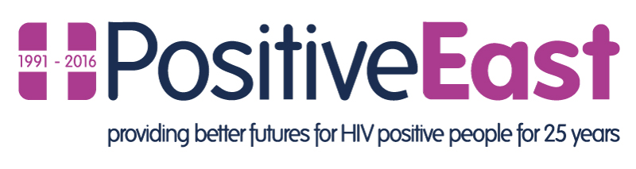Information and Advice Volunteers – what do they do?
Volunteers who give advice to our service users are at the centre of the Charity’s activities and our philosophy. We simply could not provide all the support we do, without them. As one of our Information and Advice volunteers you will receive training and support in order to help you carry out your role. All our volunteers have regular one to one feedback sessions with a supervisor. In addition, there are opportunities, for those that wish, to develop to more complex advice support cases and to move from telephone advice to face to face sessions with service users during their time with Positive East. There are a range of different roles and tasks from signposting and giving information through to giving full advice.
Experience and Skills Required
You don’t need specific qualifications or experience to train for the role but, if you do have them, then we’d love to hear from you. What you will need is:
- an ability to understand complex information
- be polite and good at listening
- good spoken and written English language skills
- be familiar with using keyboard skills and searching the internet
- be able to input data accurately
- a good level of literacy and numeracy
- be open minded and not judge clients
- enjoy helping people

For more information on what the role involves and what skills, experience and commitment we are looking for contact:
volunteering@postiveeast.org.uk or call Stewart Turnbull on: 020 7791 9308

