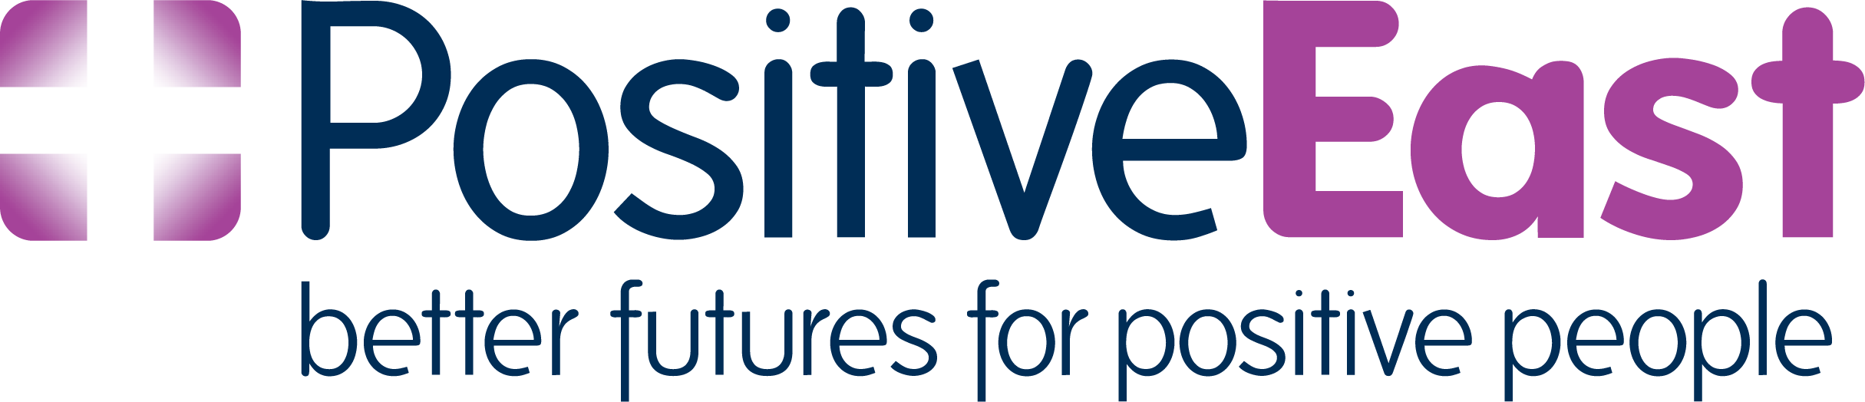

Peer Mentors
Peer Mentors are people that have an HIV diagnosis and have lived with the diagnosis for some time. They have experience of living with HIV and have gained wide knowledge on many issues, some of these include; Treatment knowledge, services available in the community, combat stigma, disclosure issues, relationships and disclosure, welfare issues, U=U undectactable equals untransmittable. Most of all they have learned to live a full life regardless of having the diagnosis.
Our experience is when people are diagnosed either at a testing clinic or at a Hospital clinic they experience a great deal of fear and nervousness and usually are left wondering how they life will be affected because of the diagnosis.
We have experience that having a peer mentor comes with lots of advantages. Taking to someone who shares the same experience can reduce isolation. It can also be reassuring and empowering to listen to someone who has lived with the condition for some time.
Our peer mentors know what it means living with the condition and have experiences of attending clinics, taking medication, navigating the healthcare system, formulating new relationships, or break away from relationships that are unsupportive or judgmental. They are compassionate and willing to share their experiences with you and to support you. In addition, to be
“Expert by experience, “they receive professional training to support them with their role of peer mentors.
They will give you the opportunity to explore some questions you may have about living with the diagnosis. Most of all they are very happy to support you.

Peer mentor role
Our peer mentors see people on a 1-2-1 basis. They support them with a variety of issues and can work with individuals for a few weeks. Their support can be face to face, via email or telephone. Some of our peer mentors provide support at some London HIV clinic and work alongside health professionals and consultants.
Some of our peer mentors also help with the running of some of our support groups, workshops and seminars.
Our peer mentors provide extremely valuable feedback and help us to improve the quality of the service.
Benefit of becoming a peer mentor
- Meeting new people
- Learn and develop new skills
- Be part of a wider network
- Opportunity to develop organization and interpersonal skills
- Obtain references after completing a minimum of three months volunteering

Testimonials from volunteer’s peer mentors

- Being a peer mentor at Positive East has been very gratifying. With the comprehensive and practical training, plus the continuous supervision, I have learnt to understand the many ways people cope and learn to live their lives, while living with the HIV virus. I have been able to share my knowledge, and to guide those who are in need to be heard, to give support and guidance through this transition in their lives.

- Peer support is the best present I can do to myself and to people looking for emotional and practical support. It's a journey of learning for me too. I have learnt that listening is such a powerful healing tool. Peer mentoring at Positive East is a beautiful service given to the community and happy to be part of it.

- I wanted to become a Peer Mentor to be part of the support system for newly diagnosed clients. When I was diagnosed, I was so ignorant towards HIV and wasn't aware of any support systems. It was hell for me. Peer Support is my way of making sure people have support dealing with their diagnoses, as well as any other underlining issues, at the beginning and throughout. The training I received for the role was outstanding, intense and thoroughly enjoyable! Any confidence issues I had prior to the training were quashed, and the support I have from the Peer Support Workers is amazing. I hope this doesn't all sound too kiss ass, I'm just speaking from the heart. I love my role as Peer Support Volunteer!

- Becoming an HIV Mentor Volunteer with Positive East has been absolutely affirming and it has given me the most comfort ever being myself, particularly being Black, Gay, Christian and HIV positive. Helping others come to terms or at least have a rethink about their diagnosis has been a great experience. I cannot hold a conversation without sharing about my HIV status. I personally think, this way we can end prejudice and stop stigma.

- I have been involved in the Peer Mentor programme for nearly three years. I’ve found the experience to be very beneficial to myself. The programme has helped me develop my own network of people living well with HIV. -It has made me more empathetic to those whose situation may be very much less privileged than my own and, I hope, more skilled in listening and helping others arrive at solutions to the issues most important to them. Thanks to all employed staff at Positive East for their sensitive and conscientious management of the programme.’

Becoming a peer mentor
We would like to hear from you if you have an HIV diagnosis and wants to support others to live well with HIV and be part of a service that works in the health and social care sector.
In return we will train you professionally with a three-day training course.
How to have a peer mentor
If you would like to receive support from a peer mentor, please get in touch and we will try and match you with a suitable mentor. We may be able to match you with a mentor of your preference.

Please contact Antonio Giacalone antonio.giacalone@positiveeast.org.uk
Tel 0207 7919314

